Universidad de San Carlos de Guatemala

Facultad de Ingeniería

Escuela de Ingeniería en Ciencias y Sistemas

Organización Lenguajes y Compiladores 1

Nombre: Selvin Lisandro Aragón Pérez

Carnet: 201701133

**MANUAL TECNICO**

**ANALISADOR LEXICO**

EXPRESION REGULAR

**//Cc | <!Cc!> | L(L|D)* | “Cc” | D+ | Simb**

**Donde:**

Cc=Cualquier Cosa

L=Letras

D=Digitos

Simb=Simbolos

TABLA DE TOKENS

|  |  |  |
| --- | --- | --- |
| **No.** | **Símbolo** | **Descripción** |
| 1 | //* | Comentario |
| 2 | <!!> | Comentario Multilínea |
| 3 | Res | Reservada |
| 4 | Id | Identificador |
| 5 | “Cc” | Lexema de Entrada |
| 6-37 | Símbolos | Símbolos |
| 38 | D | Digito |

ARBOL

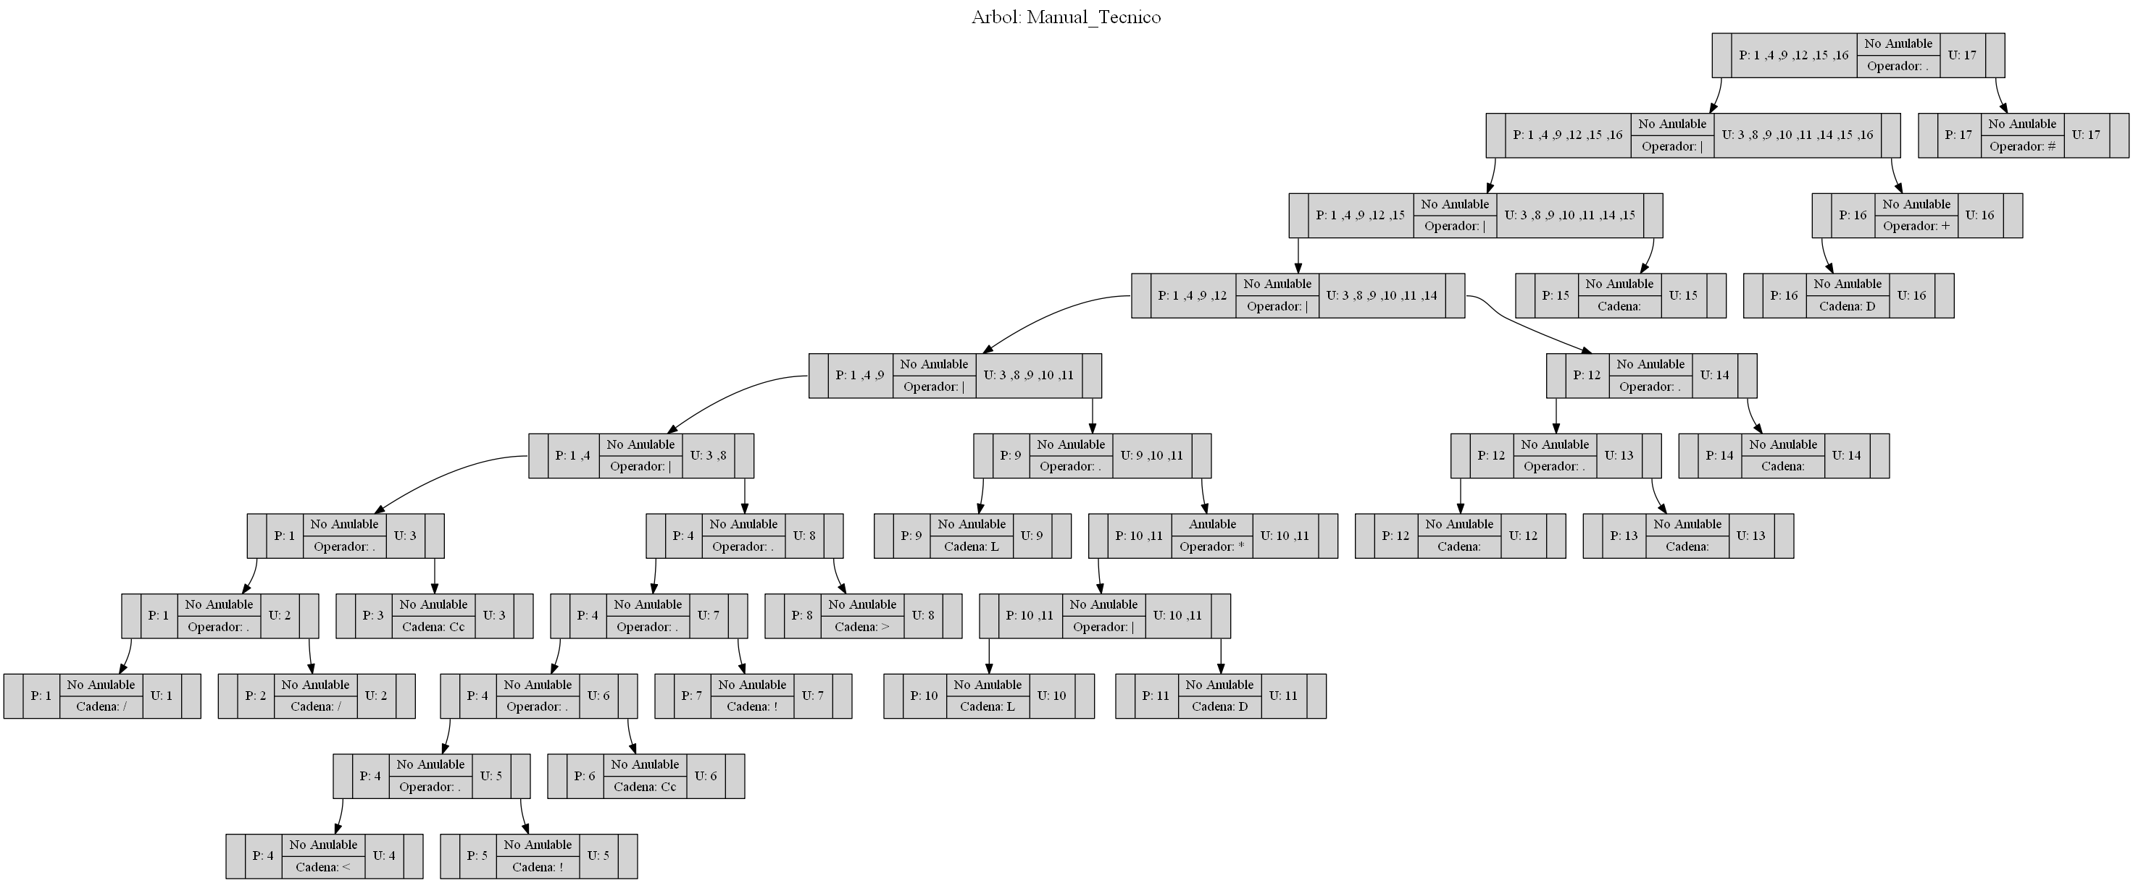

TABLA DE SIGUIENTES

|  |  |  |
| --- | --- | --- |
| **Nombre de Hoja** | **Id de Hoja** | **Siguientes** |
| "/" | 1 | 2 |
| "/" | 2 | 3 |
| "Cc" | 3 | 17 |
| "<" | 4 | 5 |
| "!" | 5 | 6 |
| "Cc" | 6 | 7 |
| "!" | 7 | 8 |
| ">" | 8 | 17 |
| "L" | 9 | 10,11,17 |
| "L" | 10 | 10,11,17 |
| "D" | 11 | 10,11,17 |
| " | 12 | 13 |
| " | 15 | 17 |
| "D" | 16 | 16,17 |
| # | 17 |  |

TABLA DE ESTADOS O TRANSICIONES

|  |  |
| --- | --- |
| **Estado** | **Terminales** |
|  | **"** | **"D"** | **"!"** | **">"** | **"<"** | **"Cc"** | **"/"** | **"L"** |
| **S0{1,4,9,12,15,16}** | **S4** | **S6** |  |  | **S2** |  | **S1** | **S3** |
| **S6{16,17}** |  |  |  |  |  |  | **S7** |  |
| **S7{3}** |  |  | **S8** |  |  |  |  |  |
| **S8{6}** |  | **S3** |  |  |  |  |  | **S3** |
| **S1{6}** | **S9** |  |  |  |  |  |  |  |
| **S9{14}** | **S5** |  |  |  |  |  |  |  |
| **S2{6,2,3}** |  | **S6** |  |  |  |  |  |  |
| **S3{6,4,6}** |  |  |  |  |  | **S5** |  |  |
| **S4{6}** |  |  |  |  |  | **S10** |  |  |
| **S10{7}** | **S5** |  |  |  |  |  |  |  |
| **S5{1,90,17}** |  |  | **S11** |  |  |  |  |  |
| **S11{8}** |  |  |  | **S5** |  |  |  |  |

AFD

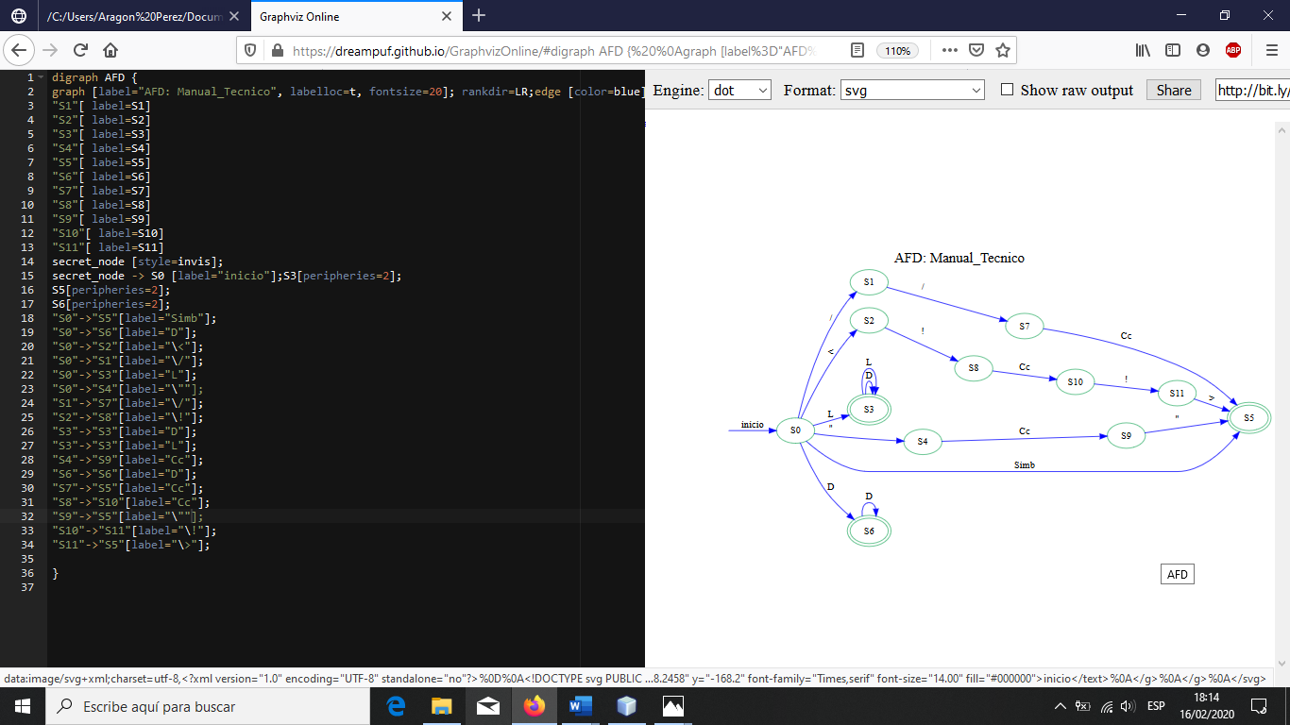

**ANALISADOR SINTACTICO (OPCIONAL)**

<INICIO> -> CONJ: Id <CONJUNTOS>  
 | Id <ER>

<ER> -> <ER2>  
 | :<LEXEMA>

<ER2> -> . <ER2>  
 | | <ER2>  
 | ? <ER2>  
 | * <ER2>  
 | + <ER2>  
 | {id} <ER2>  
 | “Cadena” <ER2>  
 | ;

<LEXEMA> -> “Cadena”

<CONJUNTOS> -> L ~ L  
 | D ~ D   
 | S ~ S  
 | {L,D,S}

**OTROS**

* IDE: Netbeans 8.2
* Lenguaje: Java
* Librerías Utilizadas:
  + Graphviz
  + java.util.*
  + java.io.*
  + java.awt.Image
* Paquetes Utilizados:
  + Estructuras
  + olc1-practica1-201701133